MUSIC PRODUCTION I
Dr. Birch

PROJECT 4:

Part I: Installing and using Audacity on your HOME COMPUTER
Download Audacity:
Go to: http://audacity.sourceforge.net/ (you may also Google “Audacity”)
Click on “Download Audacity 1.2.3”
Download:
- Audacity 1.2.6 installer (.exe file, 2.4 MB) - The latest version of the free Audacity audio editor.
- or Audacity 1.3.3 installer (.exe file, 2.5 MB) (this is a beta version)

Optional Downloads (very useful)
- LAME MP3 encoder - Allows Audacity to export MP3 files – This is very helpful -
- VST Enabler - Allows Audacity to load VST plug-ins.
- Plug-Ins - Download additional effects and filters -

PART II

Directions:

- Start Audacity
- Read the Online Help
- Explore the various toolbars and menus

Generate different waveforms

GOAL
- Use Generate to create sine, square and sawtooth waves of different frequencies and amplitudes.
- Use generate to create white noise
Start Audacity (this can be done either at home or in the computer lab)

- Go to Generate>Tone…. and select the following and click on Generate Tone
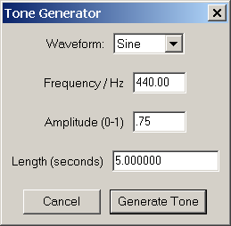
- Name the Track “Sine 440” by clicking on the full down menu and selecting Name….
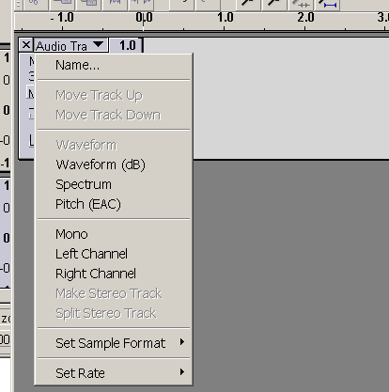

- Listen to the file
  - Use play, stop, pause rewind and forward
- Practice zooming in and out
  - You zoom in and out of the horizontal plane (time) with the + and – magnifying glass
  - You zoom in and out of the vertical plane (amplitude/volume) by clicking on the DB scale
- When you Zoom in very closely observe what a sine wave looks like

Create a new mono track

- Go to Project>New Audio Track – Repeat this step 7 Times – Now you have 8 Tracks
- Now create 5 second sine waves of frequencies: 110, 220, 330, 440, 550, 660, 770 and 880
  - Click on the second track and click Generate>Tone ….. and change the frequency to 220
  - Repeat the same procedure for the remaining frequencies.
- Zoom in until one cycle of Sine 110 takes up the entire window (for example crest to crest)
  - What is the relationship between each wave?
  - These are the first 8 Harmonics of A 110 
- Using the SOLO button listen to each track –
  - What are the pitches of the remaining 7 harmonics?
  - When the frequency doubles (110 – 220 – 440 – 880), what is the interval?
- Add three more audio tracks
- Create:
  - A Square wave: 220 Hz, .75 Amplitude, 5 seconds long
  - A Sawtooth wave: 220 Hz, .75 Amplitude, 5 seconds long
  - Zoom in and observe the waveform
  - Listen to each track. What is different?
  - Create 5 seconds of white noise: Generate>White Noise
  - What does it sound like?
What is the appearance of the waveform?
From Home
- Create a folder and name it <yourname> Project 4
- Save this project in the folder with the file name <yourname> Project 4
- Copy the folder to a removable device and copy it into your folder on the M Drive in the Music Lab.

From the Lab
- Create a folder on your M drive and name it <yourname> Project 4
- Save this project in the folder with the file name <yourname> Project 4

