MUSIC PRODUCTION I
Dr. Birch

PROJECT 3
Recording and Editing in Audacity

Part I: Installing and using Audacity on your HOME COMPUTER
Download Audacity:
Go to: http://audacity.sourceforge.net/ (you may also Google “Audacity”)
Click on “Download Audacity 1.2.3”
Download:
- Audacity 1.2.6 installer (.exe file, 2.4 MB) - The latest version of the free Audacity audio editor.
- or Audacity 1.3.3 installer (.exe file, 2.5 MB) (this is a beta version)

Optional Downloads (very useful)
- LAME MP3 encoder - Allows Audacity to export MP3 files – This is very helpful -
- VST Enabler - Allows Audacity to load VST plug-ins.
- Plug-Ins - Download additional effects and filters -

Part II:

OBJECTIVE:
Record yourself or a friend counting from zero to 9 (minimum)
You may expand this project by recording either more dialogue (humor welcome) or sounds or music.

TOOLS
Audacity: recording software
the M-Audio MobilePre
Microphone

Directions:

CREATING THE FOLDER
- Create a Folder within your folder in the MP-I Folder called: <Yourname> Project 4.
If I were making the file the directory would be:
MP-I>Birch Sebastian> Birch Sebastian Project 4

The M-Audio MobilePre
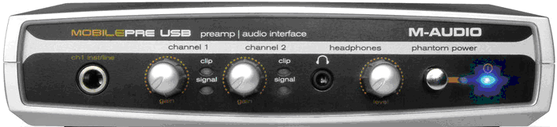
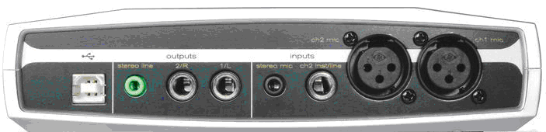

Study carefully:
- the Inputs and outputs on both the front and the back
- What do the LED’s represent?
- The function of the various knobs and buttons
- Is there a power switch?
- Where is the USB?
- What powers the interface?

Make sure that the microphone is plugged into the mic input on the back of the M-Audio Mobile Pre USB audio interface.

RECORDING WITH AUDACITY
- Start Audacity
- Save the file in your folder as <Your Name> Project 4 – Save your project often in case the computer crashes etc.
- in the MIXER TOOLBAR select Microphone (might not be necessary in the Lab)
- In the Mixer toolbar select MONITOR INPUT next to the microphone icon
- Click on the Microphone input meter bar to activate it
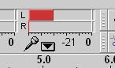
- While talking into the microphone adjust the input level on the audio interface (Channel 1 Input)
- Record yourself counting from zero to nine, also record "O" - make sure to have a gap between each number.
- Check the level of the recording and listen to the track. The goal is to have the strongest possible signal without "clipping". The strong signal makes the "background noise" less noticeable. Clipping adds distortion to the recording.
- Mute the track and record another track with the levels as high as possible and speak as loudly as possible. How is this recording?
- Zoom in on a large crest of the wave and observe its shape. What do you notice?

EDITING

- Create a new track: Project>New Track
- Solo the current track or Mute the other tracks
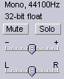
- Cut and paste the correct numbers to create the White House Phone Number: (202) 456-1414
- You can insert silence to create the correct timing. For example you will need extra time where the Hyphen is.

SAVING
- Save the project in your folder on the I drive
- Save another copy on the M drive
- Delete the phone number and export the WAV file to your folder and to the M drive – Save the File as <your name> Project 3 Recording.wav
- Close Audacity

