MUSIC PRODUCTION I
PROJECT 7
Time Warp and the Beat Calculator

GOALS:
Part A:
- “Acidize” loops, “Musical Mode”
- Use them to create a project.

Part B:
- Find a loop for “Satin Doll”
- set it to the grid using the beat calculator
- create a clip for the pickup
- slice the loop
- Create something original with the material obtained.

Part A –
- Start Cubase, select empty project
- In the “select Directory Window) Create a new folder within your own folder and name it “<your name> Project 7”
- Import all of the audio files from the MP-I Project 7 Loops folder on the S drive
  - Assign to different tracks
  - Use the following import options:
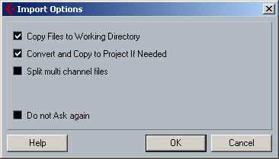
- Audition each file and give it an appropriate name
- Listen to each loop and determine how many beats there are
- Enter the Sample Editor by double clicking on a file

Working with loops in Cubase.

- Select and loop a clip
  - Count the number of beats in the clip.
- Open the Audio Editor by double clicking on the clip
  - Enter the appropriate number of beats in the bars and beats at the top of the screen
  - Turn Musical Mode on (the square music note icon)
- Close the Sample Editor

The loop should fit perfectly within the grid. Repeat on the remaining loops.

- Now create something interesting with the existing clips
  - Change the tempo
  - Slice the clips
- Save as <Yourname>Project 7 Part A

Part B – Goal: Use the beat calculator to set a loop to the Grid

- Create a new Project in the same folder
- Import the Audio File Satin Doll
- Edit the clip to remove the “pickup” and the extra counts at the end.
  - The information below is for the non music majors! Music majors should practice finding the beginning and end of loops by ear …..
  - The Downbeat starts at ~1.238 (Look at the secondary time display)
  - The loop ends at 17.518
  - You might want to “tweek” the loop length to your taste
- Either Cut the clip, or use the handle to resize the loop.
- Set the Left and Right locators
- Turn Cycle on – Does the Loop sound acceptable?
- If YES, use the beat calculator to set the loop to the grid
  - Enter the number of beats (32)
  - Select Insert Tempo into Tempo Track Start At Tempo Track Start.
- The Clip should be exactly 8 measures long
- Does the tempo hold throughout?
- Slice the loop into bars and/or beats
- Use the smaller clips to create an interesting project.
- Save as <Yourname>Project 7 Part B

