MUSIC PRODUCTION I
Dr. Birch
Project 11

OBJECTIVES:
Changing meter and tempo within a project in Cubase

READING:
Read the chapter: Working with the Tempo track, in the Cubase manual
Needed files:
4 measures of 12/8.wav
8 measures of 4/4.wav

DIRECTIONS:
- Open a new project in Cubase (make sure that you select your folder as the default directory)
- Make sure that Tempo is set to “Track” and not “Fixed”
- Import the two wave files
- Place the 12/8 file at the beginning and the 4/4 file out of the way.
- Set the grid to the first 12/8 file
  - Use the beat calculator
  - !!!!!The beat calculator only thinks in quarter notes!!!!!!
  - In 12/8 there are 48 eighth notes or 24 quarter notes
  - Place the new meter at the beginning of the tempo track
- Open the tempo track (Ctrl T)
  - Change the beginning meter from 4/4 to 12/8
  - Insert a 4/4 meter at measure 5 with the pencil tool
  - Close the tempo track
- Move the 4/4 clip to measure 5
- Highlight the clip and open the beat calculator
  - This time there are 32 beats
  - THIS TIME INSERT THE TEMPO CHANGE AT SELECTION START
- Now copy the 12/8 clip to measure 13 and the 4/4 clip immediately following. Change the meters and tempos to adjust the grid.

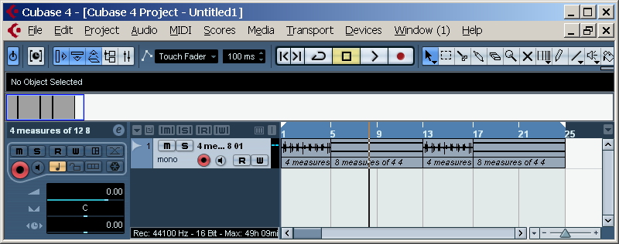
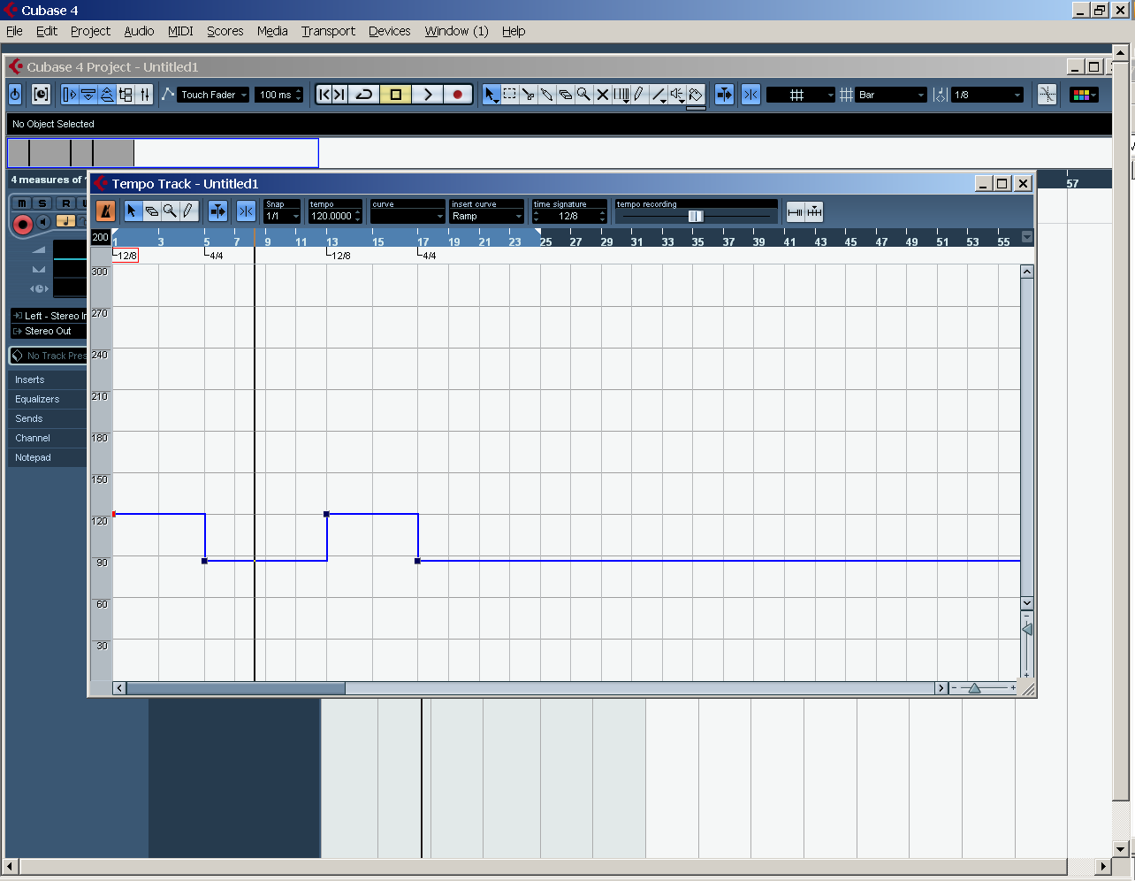

Save the file in your folder as:
<yourname>project 11

