MUSIC PRODUCTION I
Dr. Birch
Project 16
Musical and Linear Time Base
Time Warp

Read in the Cubase Manual about Musical and Linear Time Base
From the manual:

Tracks can be either musical (tempo) or linear (time) based.
• On a track using linear time base, the events will be positioned on specific time positions – changing the playback tempo will not affect the time position of events.
• On a track using musical time base, the positions of events are represented as meter values (bars, beats, 1/16th notes and ticks, with 120 ticks per 1/16th note). If you change the playback tempo, the events will play back at an earlier or later time.

Read in the Manual about The Time Warp tool:
The Time Warp tool lets you adjust the tempo track so that “musical time-based” material (positions related to the tempo) matches “linear time-based” material (positions in time). Some typical applications:
• When you have recorded music (audio or MIDI) without tempo reference or metronome click, the Time Warp tool can be used for creating a tempo map that fits the recording (allowing you to rearrange or add other material).
• When you are creating music for a movie and want to match certain positions in the video with certain positions in the music.
The Time Warp tool makes use of the fact that tracks can be based on time positions (linear time base) or positions related to tempo (musical time base.

Project 16:
Goal: Add drum parts to project 15 that start and end with scene changes and are ‘Set to the grid”
Open yourr FINISHED Project 15 from the I drive and save it as Project 16 in the same folder as P15. You will later Back it Up to the M drive when you are done.

The following is just an example – FOR YOUR OWN PROJECT YOU NEED TO CHOOSE DIFFERENT SECTIONS.

For this example we will need 4 Markers:
- Start
- Green Buggy
- Guitar Man
- Helicopter

Project
- Remove or mute the music track you added in P15
- With the SFX track set to Musical Time Base change the tempo. What happens?
- Go back to the original tempo and set the SFX Track to Linear Time Base than change the tempo again. Now what happens?
In a video project the SFX track will need to be in Linear Mode if any Tempo changes are necessary.

Setting up the beginning of the video at Measure 1
The video does not start at the beginning so we will add a count-in measure:
- Go to Project Setup (shift-S)
- Enter 1 for Bar offset
Now the project starts at measure 0, but the video is still at measure 1

- Create two one measure drum patterns: one soft and slow the other strong and fast
  - Here is an example of a possible slow pattern:
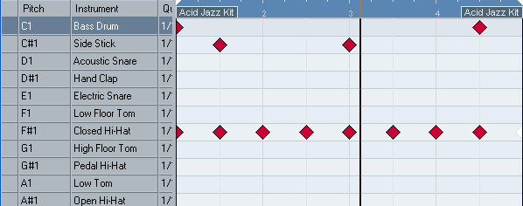
Here is an example of a fast pattern.
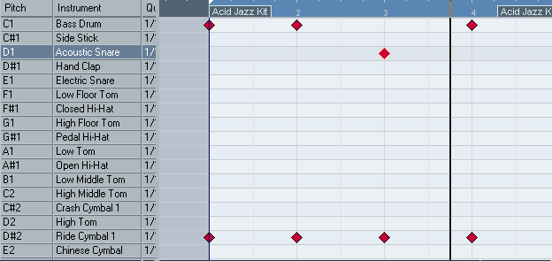

Make sure that the SFX track is set to Linear Time and that the Drum Track is set to Musical Time.
- Double click on the Start marker – This will move the cursor to that point
- Click on the Time Warp Tool and make sure that “ Warp Grid (musical events follow)” is selected.
- Using the Time Warp tool move the Measure 1 grid line to line up with the Start Marker
- For increased accuracy, zoom in as far as possible and line up the Bar 1 grid line and the cursor. When you have lined up the grid to the cursor Shift-Click and a new tempo will be inserted at that point.
- Now your drum track starts exactly with the first “active” frame of the video.
- Now copy the Slow Pattern 4 times
- with the Time Warp Tool move the Measure 5 grid line to ling up with the Green Buggy Marker – shift-click when done to insert the tempo
- Now copy the fast drum beat 4 times and with the Time Warp Tool line up measure 9 with the Guitar Man Marker - shift-click when done to insert the tempo
- Now copy the slow drum beat 4 times and with the Time Warp Tool line up measure 13 with the Helicopter Marker - shift-click when done to insert the tempo

For your project create at least 4 transitions. The above example only has three transitions.
Backup to the M drive as <yourname> MP-I Project 16

