Where to find information about your Windows computer

Some off the information can be found by just observing the computer and reading what is printed on the items. For example the Brand off the computer. The capabilities of your optic drive is usually embossed or printed on the front of the tray.
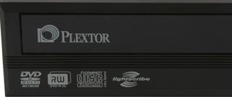

Other information can be found by right clicking on My Computer and Selecting Properties>General

Other Items can be found under Hardware>Device Manager

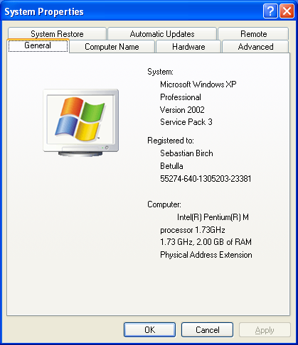

Some very specific information about the hardware on your computer is listed under Properties>Hardware>Device Manager

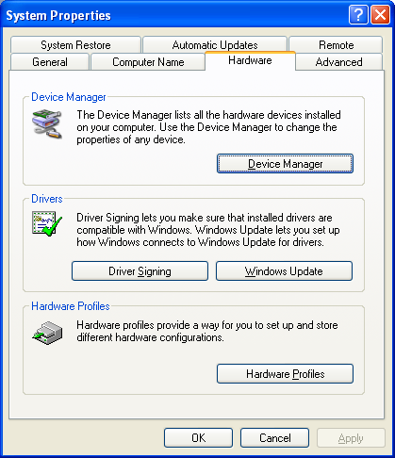 | 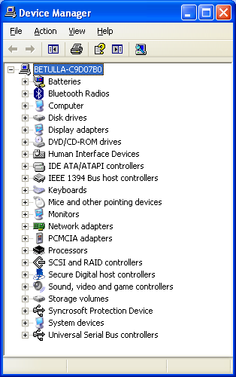

Video properties can be found by Right clicking on the Desktop and selecting Properties>Settings:
