MUSIC PRODUCTION I
FINAL PROJECT

PROJECT COMPLETION GUIDELINES

You have COMPLETE freedom on what type of music you make; nevertheless, you need to:
- Use the grid
- Label each track clearly
- Label the clips clearly
- Use a Marker Track to explain what is going on
- Use the Mixer to set the levels correctly
- The Stereo Output signal should be strong enough
- SAVE the file on “your” computer in the lab as you intend me to hear it –
- Bring the folder to class for the Final Exam. Arrive a little early if possible to copy your files to the hard drive.

WE WILL LISTEN TO ALL FILES IN CLASS

Your grade will be based on:

- Following the above procedures
- The successful rendition of your project in class
- My observations of your file in the lab
- Effort and creativity

GETTING YOUR PROJECT TO CLASS

In order to be able to listen to the final projects in class and to see the Cubase project we will need to: export the file as audio, re-import it to the project, and export the file to a new folder
- Export the file with Audio Mixdown
- Reimport the mix into the project
- Save project to new folder
- Burn the project folder to a CD or copy it to a removable drive.

In order to make an audio mixdown ALL MIDI TRACKS HAVE TO BE ASSIGNED TO VST INSTRUMENTS – If you are using Sound Blaster sounds switch to the VST Universal Module

When your project is complete:
- Set the locators to the beginning and end of the project – It is better place the right locator a few bars past the end to avoid clicks or chopped off effects at the end
- Go to File>Export>Audio Mixdown

Select:
- Wave File
- Stereo Interleave Out (stereo)
- Sample Rate 44.1
- Bit Depth 16 bit
- Import to Pool and Audio Track – This will load the resulting file into the project
- Select Close dialogue after export
- Click on Export
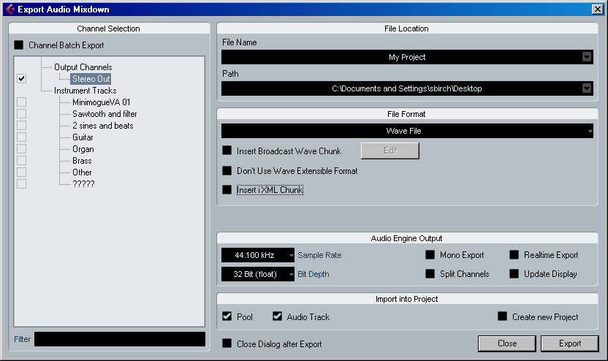

- Now you can see the new Audio file in a new track - Name it <yourname Audio Mixdown)
- Solo the Audio Mixdown Mute all of the other tracks
- Play the file – It should sound the same as the original project

If you are satisfied with the result:

- Go to File>Backup Project
- In the Select Directory window go the S drive and navigate to: MP-I>Final Projects.
- Click OK
- In the next window
  - name the project: <Yourname> Final Project
  - Minimize Audio Files (this will only write the parts of the files being used)
  - Remove Unused Files (this will prevent the unused audio files from being written saving space)
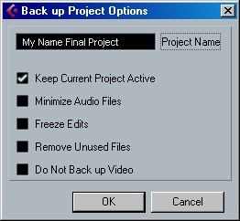
- Click OK

