MUSIC PRODUCTION I
Dr. Birch

Example Quiz 1

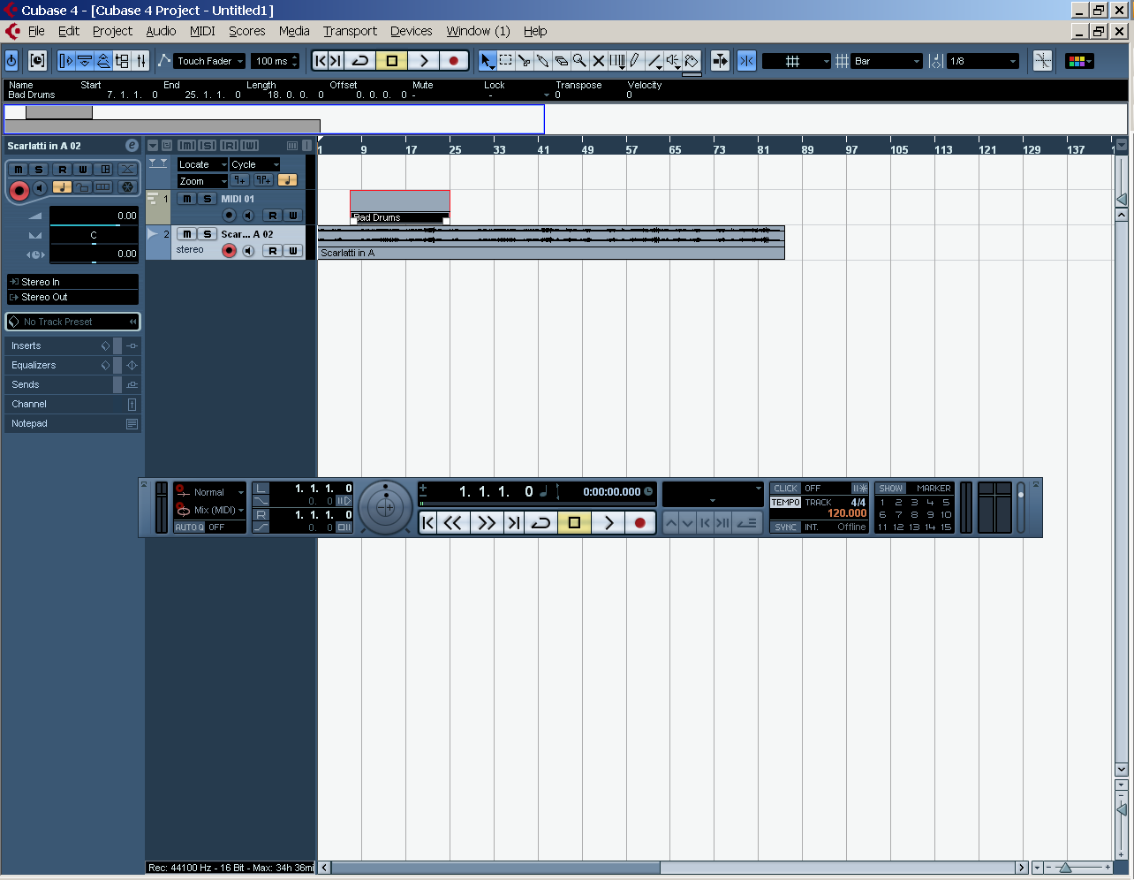

IDENTIFY the following items in Cubase by writing the corresponding number on top of the item in the picture above.

- Transport Toolbar
- Project Cursor
- Track
- Inspector
- Track List
- Event Display
- Left Locator
- Right Locator
- Snap
- Tempo Display
- Cycle
- Play
- Go to start (or previous marker)
- Rewind
- Record
- Solo
- Mute
- Track Volume
- Stop
- Clip

