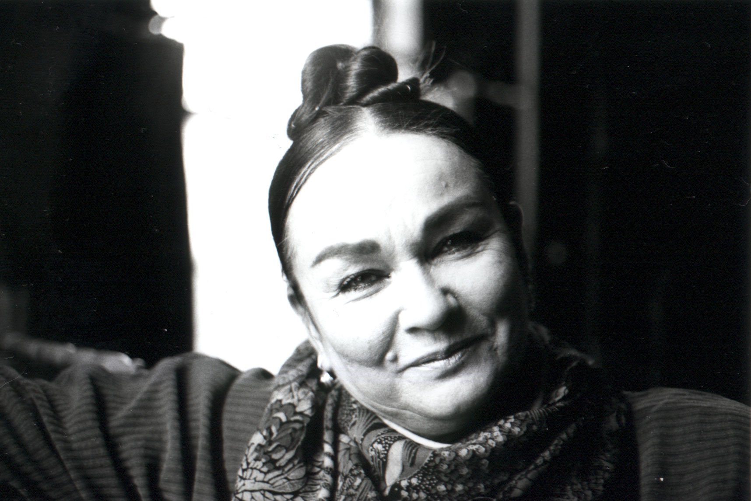
Patricia Polacco, the popular author-illustrator of more than 40 books for children, is coming to Symmes Elementary School on Monday, October 16th.
Patricia Polacco is a masterful storyteller who often goes to the heart of her own childhood for her stories. Many of Patricia’s books revolve around her Ukrainian heritage, rich family traditions and loving intergenerational relationships. Each of her books is filled with vibrant, colorful folkart illustrations and warm, deep, and uplifting wisdom. Patricia’s books have been featured on PBS’ Reading Rainbow and have appeared on the New York Times Bestseller lists. Her outstanding contributions to children’s literature have been recognized with awards from the American Library Association, The Association of Jewish Libraries, and The Children’s Book Council. Ms. Polacco’s books appeal to readers of all ages and can be read and enjoyed again and again on different levels.

During Patricia Polacco’s presentations for our students, she will bring into play the real life stories that inspired the books Meteor!, Chicken Sunday, The Keeping Quilt, My Rotten Redheaded Older Brother, and Thank You, Mr. Falker. Patricia will inspire and entertain as she regales about family and heroic teachers who influenced her life, while also touching on her learning disabilities, teasing, and how this made her feel growing up. Each presentation is geared toward the grade level involved. At the end of each presentation, students may touch a real piece of the meteor that landed on her grandparent’s farm and make a wish (from Meteor!) or they may touch the hand that has touched the hand that has touched the hand ….. that shook the hand of Abraham Lincoln. (from Pink and Say).

Books purchased through this PTO pre-visit book sale will come with a signed bookplate. (Since Ms. Polacco suffers from carpal tunnel syndrome, a school-wide book signing with students is not possible.) Parents are welcome to attend the school presentations on October 16th: 9:30 a.m. for Kindergarten & 1st grade; 10:45 a.m. for 2nd grade; and 1:45 p.m. for 3rd and 4th grades. Ms. Polacco will be speaking at the Symmes Township Public Library (next to the school) on Saturday, October 7th, at 3:30 p.m.

For more information about the author and her books, visit her website at www.patriciapolacco.com.
Many thanks to our author visit sponsors: Symmes Elementary PTO, The Sycamore Schools Foundation, and bigg’s, for their help in making this Patricia Polacco visit possible.

Patricia Polacco Book Order Form
Thank you for supporting our Symmes Author /Illustrator Visit.
Please return this form by noon on Wednesday, September 27th to your child’s teacher in an envelope marked: Author Visit Book Order. Checks should be made payable to Symmes PTO

Child’s Name:___________________________ Phone number: __________________ Homeroom: _______

Book Title | Price* | Quantity | Extended Cost
TOTALS:
Please call Karen Amster at 247-9747 with questions.
* sales tax is included in these prices Books will be sent home with students on October 16th.
Appelemando’s Dreams – Appelemando loves to dream! The villagers think he will never amount to much, but his friends know better. They can see his dreams drift right up from the top of his head and float into the sky. Then, one rainy day, Appelemando’s dreams are blown onto all the wet walls and roofs of the town, covering the houses and stores with fantastic pictures. The villagers are astonished and angry. Not until Appelemando and his friends lose their way in the forest do the villagers recognize the wonder and value of Appelemando’s special gift. With her vibrant folk-art illustrations, Patricia Polacco draws young readers into Appelemando’s magical world, where they will discover the importance of dreaming and the power of true friendship. A Reading Rainbow book Hardcover: $16.00 Paperback $8.00

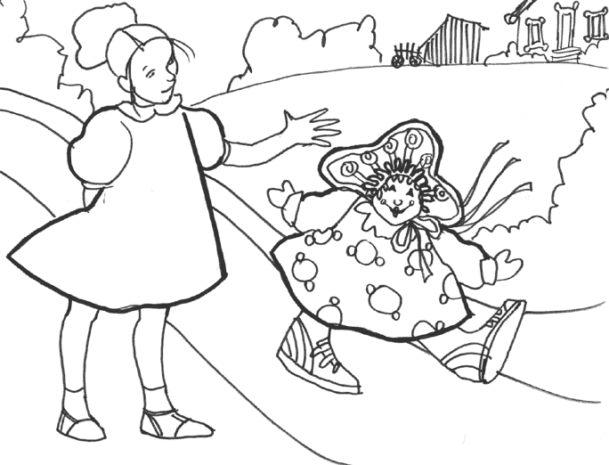
Babushka’s Doll – Babushka warns her high-spirited granddaughter, Natasha, not to play with her special doll. But, when Babushka goes out, Natasha takes the little doll down from the high shelf. The naughty doll comes to life - and is even more rambunctious than the little girl herself. Patricia Polacco’s beautiful illustrations capture the warmth, humor, and timeless spirit of her magical tale.
Hardcover:$16.00 Paperback: $8.00

The Bee Tree – “So you don’t feel like reading, eh? Feel like running, do you? Then I expect this is just the right time to find a bee tree!” And off Grampa and Mary Ellen go, chasing after the bee they’ve let loose from the jar, following it back to its hive and the sweetest honey in the land. Townspeople they meet along the way join in the chase. But it is not until everyone returns home to celebrate the sweet find that Mary Ellen makes a discovery of her own: Sometimes, even the sweetest of things must be worked for. With exuberance and charm, artist and master storyteller Patricia Polacco celebrates the unexpected joys – and true adventure – of reading itself! Hardcover: $16.00 Paperback $8.00

The Butterfly – Since the Nazis, with their tall boots, have marched into Monique’s small French village, terrorizing it, nothing surprises her. It is war! Then, one night, Monique encounters “the little ghost” sitting at the end of her bed. When she turns out to be – not a ghost at all - but a young Jewish girl named Sevrine, who has been hiding from the Nazis in Monique’s own basement, how could Monique not be surprised! Playing secretly after dark in Monique’s room, the two become friends, until, in a terrifying moment, they are discovered, sending their families into a nighttime flight. In turns heart-wrenching and touching, Patricia Polacco once again dips into her own family’s history to reveal this passionate and true tale of friendship from the French Resistance. Hardcover: $16.00

Chicken Sunday – More than anything in the world, the children want to buy that special Easter bonnet in Mr. Kodinski’s shop window for their Miss Eula. She is always so good to them, and how they love to hear her sing – her voice is like slow thunder and sweet rain. But the children do not have enough money to buy the hat. Then one day, when they are mistakenly accused of throwing eggs at the shopowner’s window, they discover just the right way to prove their innocence – and earn money for the hat at the same time. With her characteristic full, vibrant colors and rich folk-art style, author-artist Patricia Polacco once again reaches into her childhood and weaves a lasting story of acceptance, trust, and love. Hardcover: $16.00 Paperback: $8.00

Christmas Tapestry – Master storyteller and artist Patricia Polacco has outdone herself in this poignant holiday tale of two families, two faiths, and two lonely people united by a beautiful twist of fate.When a bad leak ruins the sacristy wall in his father's church, Jonathan Jefferson Weeks thinks his family's first Christmas Eve service in Detroit will be ruined, too. Luckily, he and his father find a beautiful tapestry for sale in a secondhand shop. Just the thing to cover the damaged wall and give the church a festive look! But there is more to the tapestry, as they discover when an old Jewish woman who is visiting the church recognizes the beautiful old cloth. It is her discovery that leads to a real miracle on this unforgettable Christmas Eve. This timely tale of love and generosity between people of different religious faiths is a wonderful showcase for Polacco's art. It features snowy holiday scenes and a colorful tapestry that is almost a character in itself. Hardcover: $16.00

The Graves Family – When the Graves Family moves into the creaky old house on the hill, everyone in Union City is a little scared. Sure, they seem like nice people – but why did they paint the house the color of blood? And is it true they let giant spiders run free in the parlor and have a secret laboratory in the basement? Creepy! But Seth and Sara Miller, the kids next door, are braver than most, and decide to help the Graveses make friends. Maybe if Mr. Graves gives all the bald men in town his amazing hair-growing tonic, which he developed from cat fur? It seems like a great idea – until the town council starts chasing birds and running up trees! Will the Graves family ever find a way to fit in? This book is one of Patricia Polacco’s funniest ever, with wild colorful illustrations and wonderfully creepy details. And it has a beautiful message as well: Don’t fear differences…celebrate them! Hardcover: $16.00

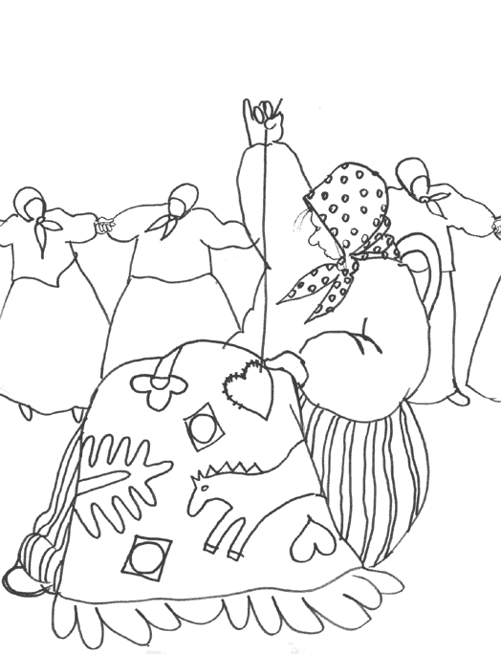
The Keeping Quilt – “We will make a quilt to help us always remember home,” Anna’s mother said. “It will be like having the family in backhome Russia dance around us at night.” And so it was. From a basket of old clothes, Anna’s babushka, Uncle Vladimir’s shirt, Aunt Havalah’s nightdress and an apron of Aunt Natasha’s become The Keeping Quilt, passed along from mother to daughter for almost a century. For four generations the quilt is a Sabbath tablecloth, a wedding canopy, and a blanket that welcomes babies warmly into the world. In strongly moving pictures that are as heartwarming as they are real, Patricia Polacco tells the story of her own family, and the quilt that remains a symbol of their enduring love and faith. Hardcover $16.00 Paperback: $8.00

Luba the Wren – When Luba helps a frightened wren, it promises to grant all of her wishes. "I am content, I have no wish," Luba says-at first. Then Luba's parents convince her to ask for a bigger house. After that, they want an estate, and later, they ask for a palace. With the granting of each wish Luba hopes her parents will be satisfied, but instead they only want more. Where will it end? This Russian version of The Fisherman and His Wife masterfully illustrates the rewards of simplicity and the dangers of greed. Hardcover: $16.00 Paperback:$8.00
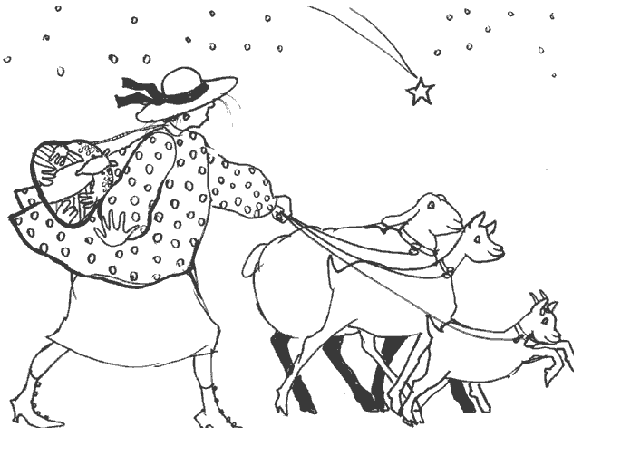
Meteor! “Why it’s a fallen star!” Grampa gasped. “And to think it landed smack-dab in the middle of our yard,” Gramma exclaimed. So began a series of fantastic (and hilarious!) events never before seen in the quiet little town of Union City, Michigan. Meteor madness had struck, and Grampa and Gramma’s farm soon became a carnival of meteoric happenings…Meteor music was played, meteor balloon rides were offered, and the circus even gave a meteoric performance. But most of all, the whole town talked. Was it a meteor with magical powers? Who can say for sure? But one thing is certain, all who saw, and especially those who touched the meteor, felt special – REALLY SPECIAL. After all, it’s not every day a meteor falls in one’s backyard. Hardcover: $16.00 Paperback: $8.00

Mr. Lincoln’s Way - He led Eugene to the window of the atrium. It was alive with the songs of the birds. ‘I see sparrows, jays, cardinals, nuthatches and the mallards. Don’t all of those beautiful types and colors make this a beautiful place to be – for all of them?’" In Patricia Polacco’s new book, Mr. Lincoln’s Way, a bully overcomes his prejudice when an African American principal invites him to help attract birds to the school atrium.
Hardcover: $16.00

Mrs. Mack – Patricia is thrilled when her father decides that she's finally old enough to learn to ride. But her dreams of having a beautiful horse of her own are dashed when he takes her to a stable in Dogpatch, the rundown section of town. Patricia is sure that she'll never learn anything in a place like that. But it's in Dogpatch that Patricia meets two individuals--kind, patient Mrs. Mack and a glorious chestnut mare named Penny--who help her overcome her fears, and change her life forever. Powerfully written, beautifully told, and brought to life with rich watercolor illustrations, this is a story that will touch the heart of everyone who reads it.
Hardcover: $16.00 Paperback:$8.00

My Rotten Redheaded Older Brother - There’s nothing worse than a rotten redheaded older brother who can do everything you can do better! Patricia’s brother Richard could run the fastest, climb the highest, and spit the farthest and still smile his extra-rotten, greeny-toothed, weasel-eyed grin. But when little Patricia wishes on a shooting star that she could do something – anything – to show him up, she finds out just what wishes – and rotten redheaded older brothers – can really do. Patricia Polacco’s boldly and exuberantly painted pictures tell a lively and warmhearted tale of comic one-upmanship and brotherly love. Hardcover: $16.00 Paperback:$8.00

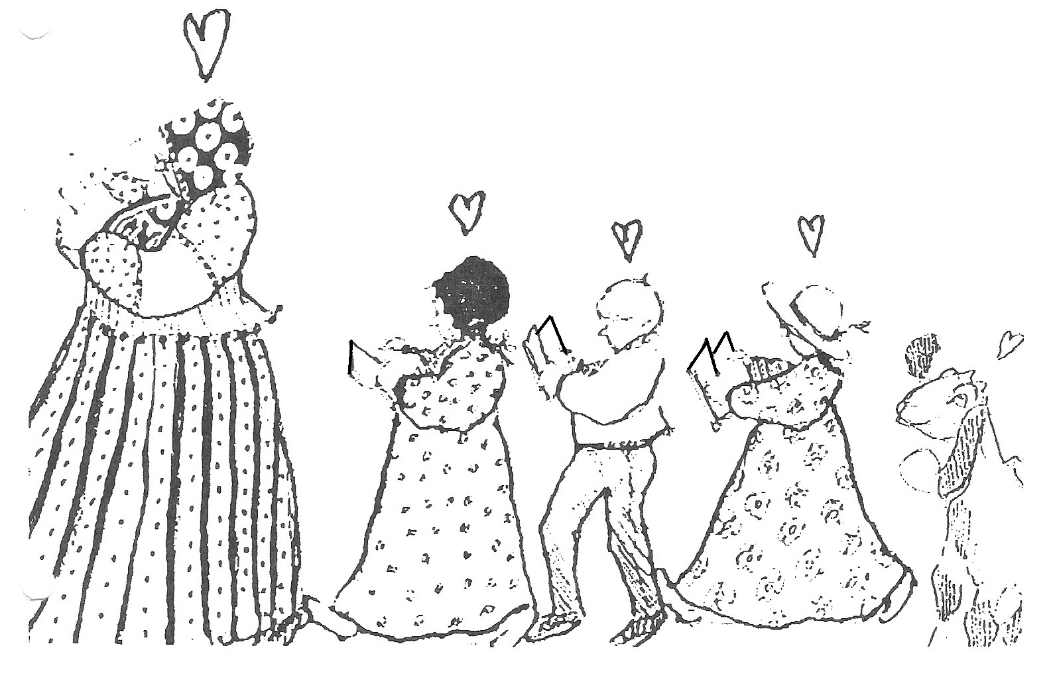

Oh Look! – “Can’t go over it, can’t go under it, can’t go around it… Let’s go through it!” When three little goats find the gate to their pen unlocked one fine day, a wonderful adventure begins! The goats go over a bridge (click, click, click!), through some mud (squish, squish, squish!), and onto a carousel (um-pah-pah, um-pah-pah!). But when their antics lead them into the path of an angry ogre, those three little goats can’t retrace their steps fast enough! Patricia Polacco has crafted another light, fun, enchantingly illustrated picture book for the very young, featuring her favorite animals. Hardcover: $16.00

An Orange for Frankie – The Stowell farmhouse is bursting at the seams with holiday spirit. But there’s a cloud over the joyous season: Tomorrow is Christmas Eve, and Pa hasn’t returned yet from his trip to Lansing. He promised to bring back the Christmas oranges for the mantelpiece. Every year there are nine of them nestled among the evergreens, one for each of the children. But this year, heavy snows might mean no oranges…and, worse, no Pa! Will Christmas really be Christmas this year? This is a holiday story close to Patricia Polacco's heart. Frankie was her grandmother's youngest brother, and every year she and her family remember this tale of a little boy who learned--and taught--an important lesson about giving, one Christmas long ago. Hardcover: $16.00

Pink and Say – Say was wounded in a fierce battle and left for dead in a pasture somewhere in Georgia when Pinkus found him and carried him to where his mother, Moe Moe Bay, lived. She had soft gentle hands and cared for Say and her Pink. But the two boys were putting her in danger, two Union soldiers – one black, one white – in Confederate territory! They had to get back to their outfits. Scared and uncertain, the boys were faced with a difficult decision, and then marauding Confederate troops rode in. In this Civil War story passed from great-grandfather to grandmother, to son, and finally to the author-artist herself, Patricia Polacco once again celebrates the shared humanity of the peoples of this world. Hardcover: $16.00

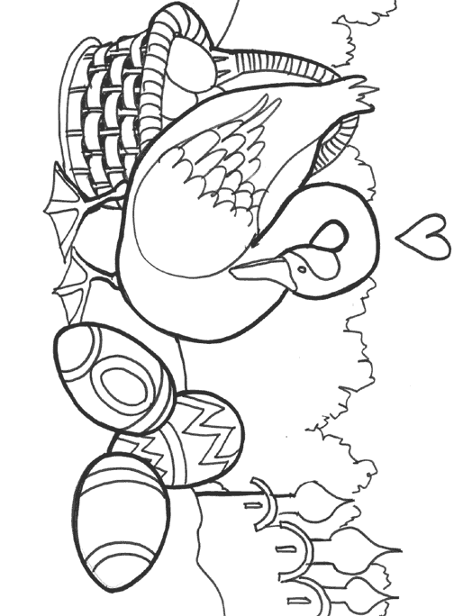
Rechenka’s Eggs – Old Babushka, known throughout all of Moskva for her beautifully painted eggs, is preparing for the Easter Festival when she takes in an injured goose. She names the goose Rechenka and they live happily together until one day when Rechenka accidentally over-turns a basket, breaking all of Babushka’s lovingly crafted eggs. But the next morning Babushka has a surprise awaiting her in the basket. She cries: “A miracle!” It is one of many in this charmingly told tale of friendship and caring. With vibrant, full-color illustrations, Patricia Polacco has joyously re-created the flavor of Old Moscow and its festivals. The eggs, stunningly colored and intricately designed, are authentic reproductions of eggs painted in the Ukrainian style. A Reading Rainbow book
Hardcover: $16.00 Paperback:$8.00

Rotten Richie and the Ultimate Dare - Seems like Richie’s entire goal in life is to make Trisha’s impossible. Especially when he takes to teasing her about her beloved ballet class. Trisha knows how much work it takes to be good at ballet—much more than that hockey that Richie plays! So she challenges Richie to perform in her ballet recital, and Richie agrees, under one condition: Trisha has to join his hockey team for the big game! This hilarious follow-up to My Rotten Redheaded Older Brother is a sibling swap of slippers and skates that will leave you cheering for both sides. Hardcover: $16.00

Something about Hensley's! – new
No matter what you need, that general store is sure to have it. It's almost magical the way the manager, Old John, seems to know what the townsfolk need before they do! But then a new family moves to town. The youngest child, Molly, has asthma—but her mother doesn't have money to treat her, or for anything else. But leave it to Old John to find a way to use Hensley's to give the family exactly what it needs, even if it can't be boxed or bagged. A true—and truly moving—story about an unforgettable general store and about the extraordinary power one person's acts of kindness can have on another. Hardcover: $16.00

Thank You Mr. Falker – “You’re going to read – I promise you that.” Little Trisha is overjoyed at the thought of starting school and learning how to read. But right from the start, when she tries to read, all the letters and numbers just get jumbled up. And her classmates make matters worse by calling her “dummy” and “toad”. Then, in fifth grade, a new teacher comes. He sees right through the sad little girl to the artist she really is. And when he discovers Trisha’s secret – that she still can’t read – he sets out to help her prove to herself that she can. And will! The autobiographical Thank You, Mr. Falker is a story close to author Patricia Polacco’s heart. It is her personal song of thanks and praise to teachers like Mr. Falker, who quietly but surely change the lives of the children they teach. Hardcover: $16.00
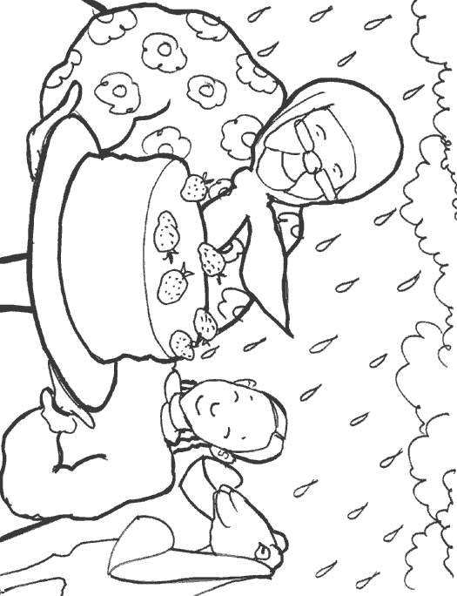
Thunder Cake – A loud clap of thunder booms and rattles the windows of Grandma’s old farmhouse. “This is Thunder Cake baking weather,” calls Grandma, as she and her granddaughter hurry to gather the ingredients around the farm. A real Thunder Cake must reach the oven before the storm arrives. But the list of ingredients is long and not easy to find … and the storm is coming closer all the time! Reaching once again into her rich childhood experience, Patricia Polacco tells the memorable story of how her grandma – her Babushka – helped her overcome her fear of thunder when she was a little girl. Ms. Polacco’s vivid memories of her grandmother’s endearing answer to a child’s fear, accompanied by her bright folk-art illustrations, turn a frightening thunderstorm into an adventure and ultimately…a celebration. Hardcover: $16.00 Paperback: $8.00

