Lab 2 Virtual PC and Windows IP Configuration

The purpose of this lab is to familiarize you with Virtual PC and to look at the way you configure IP on a Widows computer.

The Vitrual PC program is installed on the computers in the College of Business computer lab.

Copy Virtual Machine configurations to your computer
Open the “My Computer” window and select “Map Network Drive” from the “Tools” menu. .

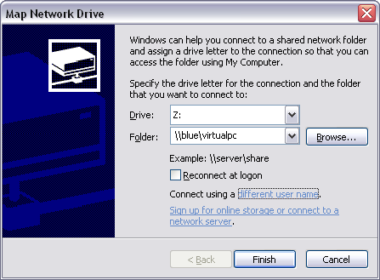
Click on “different user name” and type in “virtualpc” for the user and “vpc123” for the password.
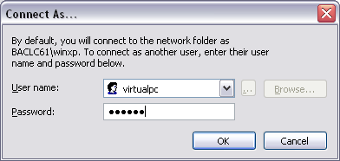Click “ok” Enter \\blue\virtualpc for folder and click “finish”. A window should open with the contents of a folder on the blue server. Right click on “my virtual machines” and select “send to” “my documents” (click “yes to all”) This should copy the virtual computer configuration information to your computer. Close the window showing the contents of the folder on the \\blue\ server-- so you don’t accidentally try to run the virtual machines directly from the server.

Enable loopback adapter

For the virtual networking to work you must enable the loopback adapter on the host computer. Click on Start, Network Connections, right click on Loop Back Adapter (may be labeled “virtual pc”, click on enable.
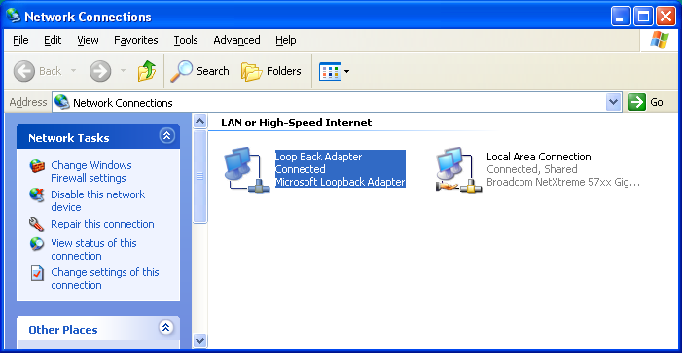

Part 1, Run Virtual PC

Open “My Documents” and drill down into the XP directory as shown in the figure below. Double click the XP.vmc icon (Virtual Machine Setting File) and wait for the virtual computer to boot.
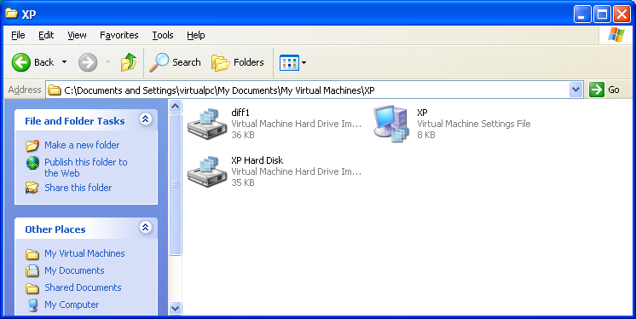

The virtual computer desktop should look like this.

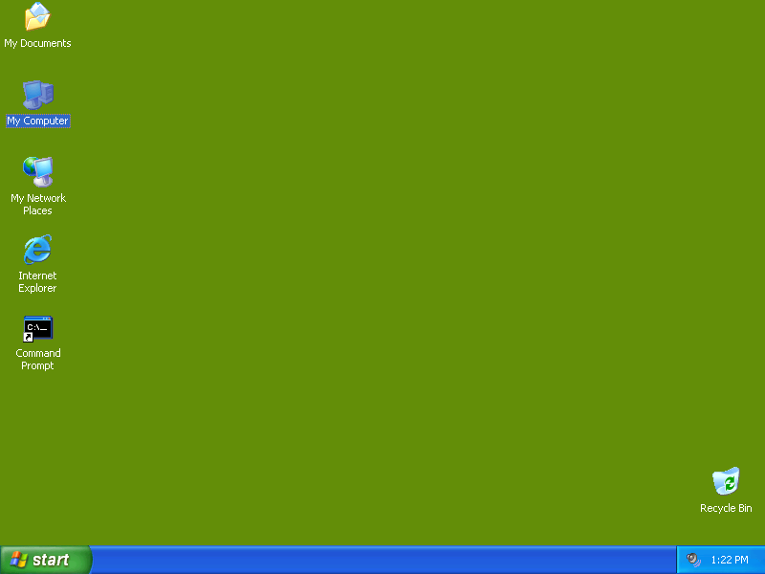

Do the Hands-On Projects 4-1, 4-2, 4-3, 4-4 and 4-5 starting on page 185 in the book. Take screen snapshots to show that you have done the tasks. Read the following notes BEFORE you try each step in the projects. Unless instructed otherwise perform the tasks on the virtual computer.

Project 4-1

1. command prompt shortcut is on the desktop
2. Perform steps 2 and 4 on BOTH the virtual and host computers. How do the two configurations relate to each other? For example, make statements like: “The default gateway on the _____ computer is the ip address of the ______ computer” where the blanks are virtual and host.
6. DO NOT do step 6 on the host computer.. Doing so would really mess up the virtual computer… WHY???

Project 4-2

1. My Network Places is on the desktop. Do steps 1,2 and 3 on both the virtual and host computers. Virtual machine only for the other steps
6. For a “valid ip address” use an address like 192.168.0.x where x is a number between 2 and 254. Use your host computer’s virtual ip address for the default gateway and DNS server.

Project 4-3

Use the Vista784.vmc virtual machine in the Vista folder. It is configured to use 784 MB of RAM The password for the user account is password all lower case.

Project 4-5

You can use the host computer for this project. Create a temp folder in the root of the C: drive before you enter the command get rfc1816.txt "c:\temp\rfc.txt"

