Lab 1 Network Management

The objective of this lab is to familiarize you with tools and techniques that will be used in later labs.

Most of the labs will require you to do something on the computer and save the results in your report. How will you get these results and where will you put them? When working in the BSA computer labs you can save your results to a USB drive, CD or even DVD depending on which room you are in. You can also email your file to yourself, or map a drive to the samba server. Your choice as to which method to use, but plan ahead.

Screen Shots.

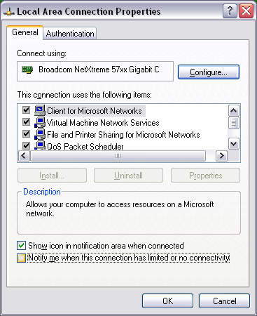
From time to time you will need a “proof of purchase” to show that you have done something. The approach you will use depends on what you are going to capture from the screen, graphics or text. The easy way to capture a graphics image is to click on the window you want and type alt-PrintScreen. This will copy the image to the clip board, you can then paste it into a word document. For example, a shot of my Local Area Connections is shown here.

Although you can use this same technique for text windows it wastes a lot of file space. I prefer text screens to be captured via the edit capabilities of command line windows. You might want to turn the “quick edit” features of the command window on as shown below. (right click on the title bar of the command window and check the quick edit box, you might also want to change the layout and font size to suit your needs. The easy way to start the command window is from the start button, select run and type in cmd to run a command window. You can now copy by holding down the left mouse button and moving over a rectangle of text. You can then past the content into your report. Change the text font to a fixed spaced font like courier and set font size so that the text is vertically aligned not wrapped.

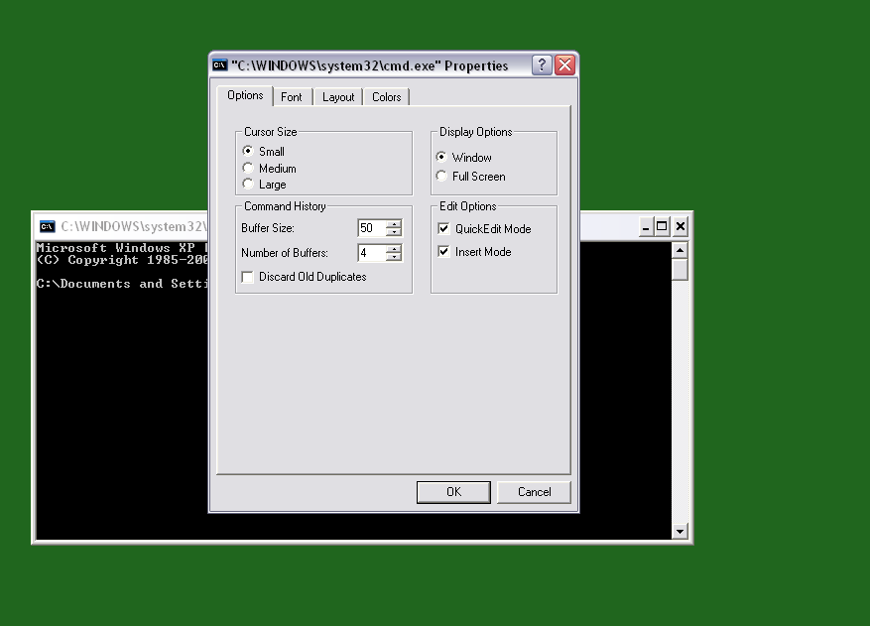

So NOT like this:
Active Connections

Proto Local Address Foreign Address State
TCP buffalo:netbios-ssn officetrac.bsa.kent.edu:2204 ESTABLISHED
TCP buffalo:2322 flash01.uis.kent.edu:http ESTABLISHED
TCP buffalo:2325 flash03.uis.kent.edu:imap ESTABLISHED
TCP buffalo:2339 flash01.uis.kent.edu:http ESTABLISHED

D:\SNMP_Session-0.89\test>

But like this:

Active Connections

Proto Local Address Foreign Address State
TCP buffalo:netbios-ssn officetrac.bsa.kent.edu:2204 ESTABLISHED
TCP buffalo:2322 flash01.uis.kent.edu:http ESTABLISHED
TCP buffalo:2325 flash03.uis.kent.edu:imap ESTABLISHED
TCP buffalo:2339 flash01.uis.kent.edu:http ESTABLISHED

D:\SNMP_Session-0.89\test>

Mapping a Network Drive

You may map a drive to a file share on the KSU SAMBA server, using your Flashline credentials (username and password). This will only work when your computer is connected to the University network, it will not work from off campus – it is blocked by the fire wall.

From the Tools menu on a Windows Explorer window (“My Computer”) Select “Map a Network drive”. In the Folder window type \\www.personal.kent.edu\username where username is your Flashline user name. Click on “connect using a different user name”. Enter kent\username again use your Flashline user name as user name.

Click on Finish, soon your home directory on the server should appear. Create several folders and files on the server. Copy a file from the server to your local computer. Open the “My Computer” window, the mapped drive should appear. When you are done you should disconnect your network drive, either right click on the drive icon or use the tools menu.
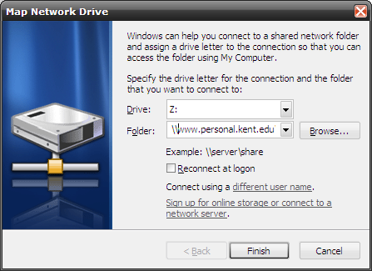

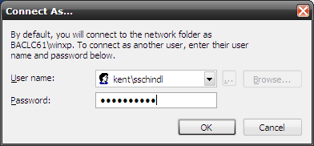

Windows Networking

With the preliminaries out of the way, let’s get down to some real work. Right click on “My Computer”, click on properties and select the Computer Name tab.
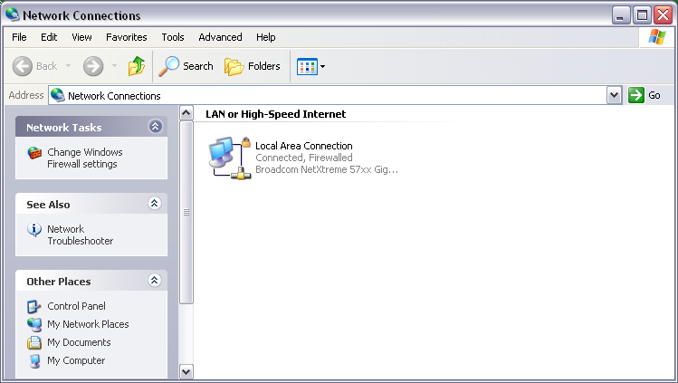
What is your computer’s name and its workgroup? What is a workgroup? Go to “Netowork Connections” from the Start button. Right Click on “Local Area Connections” select properites. [some of the names might we slightly different]

What type of network card does your computer have?

Click on each item in the “This connection uses” window,

What is the purpose of “Client for Microsoft networks”,
“File and printer sharing for Microsoft networks” and
Internet Protocol?

If you are in the computer lab look at the properties of the “virtual pc” network.

Lab hand in protocol

You may cut the questions from the lab description to your lab report. Do not include parts of the description, other than the questions in your report. Answer all the questions. Take a few “screen snapshots” (alt-Print Screen, then paste into Word) to show that you have done the tasks. Email your report as an attachment to me with the subject line: NM, Lab 1, lastname, firstname Make sure that Network Management, Lab 1 and your name is also on the report itself

